FOR SALE
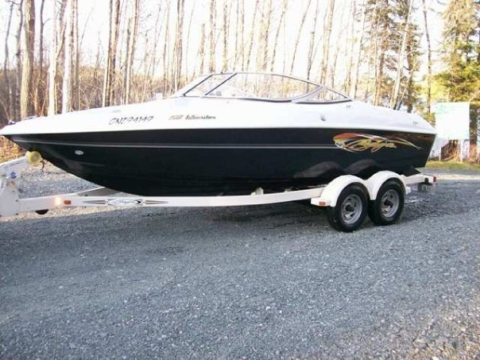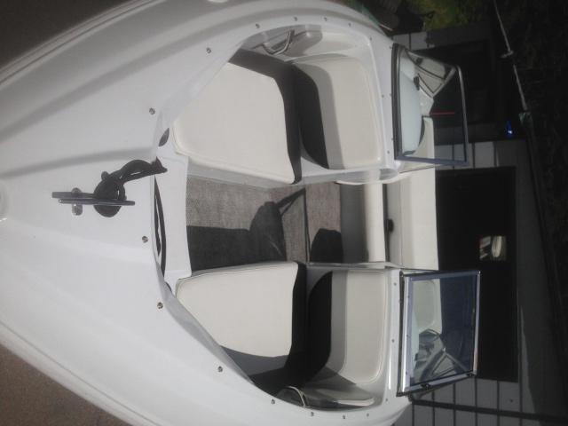
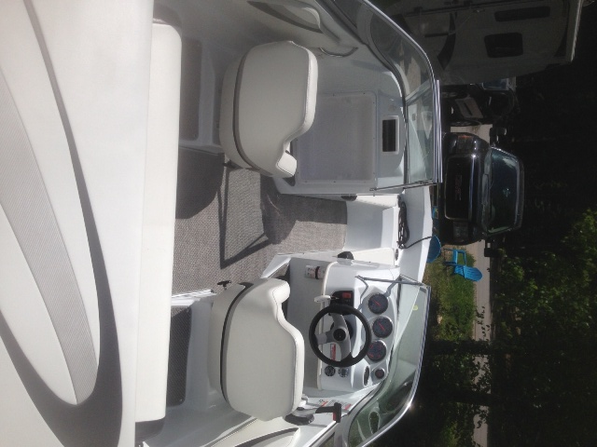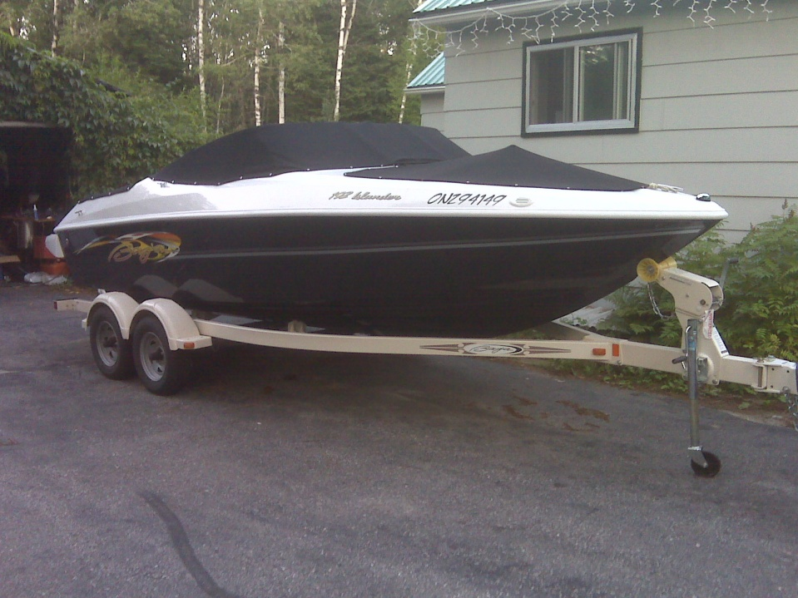
2007 Baja Islander 192. V8 220hp - Thru Hull exhaust - Has only 63 hrs on. 2 stainless steel props, mooring cover + trailering cover.
Shorelander Tandem Bunk Trailer w/brakes + swing tounge. Water Ready!
In excellent condition! FAST FUN & LOUD
For further information contact 807-464-3933

