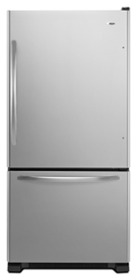
View Larger
- Email
- Print

21.9 cu. ft. ENERGY STAR® Qualified Bottom-Freezer Refrigerator
This 21.9 cu. ft. ENERGY STAR® qualified bottom-freezer refrigerator features an EasyClose freezer drawer system and four adjustable Spillsaver™ glass shelves
Color |  | Model # | MSRP*
 | Black | ABB2224WEB | $1249.00
 | White | ABB2224WEW | $1249.00
 | Stainless Steel | ABB2224WES | $1449.00
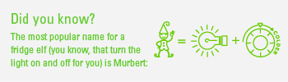

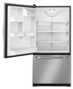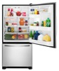
Controls
Control Type | Electronic

Performance
Energy Star | Yes
Freezer Capacity | 6.30 Cu. Ft.
Refrigerator Capacity | 15.60 Cu. Ft.
Total Capacity | 21.9 Cu. Ft.

Dimensions
Height To Top Of Cabinet | 68 1/2 Inches
Height To Top of Door Hinge | 69 15/16 Inches
Depth With Door Open 90 Degree | 62 Inches
Depth Closed Excluding Handles | 30 7/8 Inches
Depth Closed Including Handles | 33 3/8 Inches
Depth Excluding Doors | 28 1/8 Inches
Width of Cabinet Only | 32 5/8 Inches

Freezer Features
Number of Baskets | 1
Basket 1 Description | Upper Basket
Basket 1 Type | Slide-Out
Basket 1 Width | Full Width
Basket 2 Description | Lower Basket
Basket 2 Quantity | 1
Basket 2 Glide Type | Glide-Out Freezer Basket
Basket 2 Width | Full Width
Freezer Compartment Lighting | 40 Watt Blue

Refrigerator Features
Door Bin Description | Adjustable Door Bins
Door Bin Quantity | 3
Door Bin 3 Description | Opaque Std
Door Bin 3 Quantity | 1
Drawer 1 | Humidity-Controlled Garden-Fresh™ Crisper Drawer
Drawer 1 Description | Crisper Pan Cover
Drawer 1 Quantity | 1
Drawer 1 Width | Full Width
Drawer 2 | Deli Drawer
Pan 1 Quantity | 2
Pan 1 Width | Half Width
Pan 2 Quantity | 1
Pan 2 Width | Half Width
Total Shelves | 4
Shelf 1 Width | Half Width
Shelf 2 Quantity | 1
Shelf 2 Width | Half Width
Control Location | Top Right Hand Corner
Lighting | 2- 40 Watt Blue

Quality Construction
Cabinet Color | Black
Handle Material | Metal
Door Style | Flat
Base Grille Color | Black

Electrical Requirements
- 15Amps. 60Hz. 120V.

